**BEE lab evaluation Phase-1**

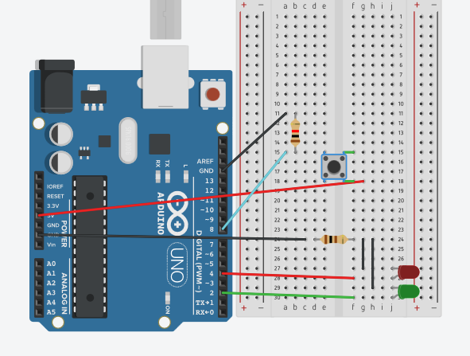

***Concept Used : -***

A circuit is made in which 3 digital pins are used where a pin (lets say 7) is

connected to a red LED which is further connected to ground.

A circuit is made in which 3 digital pins are used where a pin (lets say 5) is

connected to a green LED which is further connected to ground. Now another pin

(lets say 2) is connected to switch. One end of the switch is connected to 5V

supply and intersection of pin 2 and switch is connected to resistor which is

connected to ground from another end. Value of resistance is very high. The

resistors are used to resist the flow of current. Coding is done in such a way that

when switch is pressed or when the gas burner starts green led starts blinking and after 2000ms red led starts blinking.

.

***Learning and Observations : -***

• Making circuits using Arduino.

• Connecting LEDs and switch with arduino.

• Ground has least resistance.

• Working of Arduino.

***Problems & Troubleshooting: –***

Problem in understanding the question and executing the code and the circuit.

Because unable to understand which sensor should be used as well as how to stop a led after a particular time as after 2000ms green led is to b stoped and red has to blink.

***Precautions :–***

1. The circuit made can be wrong.

2. Any Element used may be defective.

3. The coding done can be incorrect due to which stimulation can be failed.

4. Port Selection for Arduino can be incorrect due to which it won’t upload on

Arduino Board and resulting in failure of experiment.

***Learning Outcomes: –***

1. Setting up circuit on a Arduino.

2. Connecting switch, LED and Arduino.

3. Using switch and LEDs.

4. Working of Arduino.

***Result: –***

Working of Two LEDs and switch verified after uploading the program.